
Property Sourcing Assistance
2016



An overview of the property sourcing assistance offered to new starters

Support of a locally based - German/English speaking Property Sourcing Agent (Makler):
Serco Services GmbH is represented by locally based Property Sourcing professional (Makler) Bena Roberts.
Bena provides professional and reliable Property Sourcing assistance to Serco employees based at the ECB, she is a proven expert on Frankfurt, Darmstadt and surrounding areas and offers a wealth of expertise to assist you with sourcing and securing furnished or un-furnished property.
Your Property sourcing agent will offer a relocation solution tailored to your individual circumstances and provide expertise throughout the entire relocation process.

Complimentary flight (or travel expenditure):
Single flight (or refund of fuel costs) to Frankfurt Main
Single Flight / travel expenditure also offered to partner + dependants that follow within six months of employee start date.

Complimentary registration Services Provided by Move-Concept:
i. Application for residence permit
ii. Application tax wage document/personal tax ID number
iii. Assistance in finding and registering dependants at School / Kindergarten

Financial assistance provided by Serco.
Serco Services GmbH can offer an Interest loan to assist with the initial cost related to acquiring accommodation sourced through your agent.
Upfront moving costs will generally involve the following (this may vary);
2 months deposit furnished or 3 months deposit unfurnished.
1 month in rent advance (and/or part rent dependent on moving in date).
Final cleaning charge (generally in furnished property only)

The Interest free total loan amount guideline is limited to the net income of a single month salary.
The loan is interest free, deductible from salary with the option to repay over the following terms;
12 Months,
18 Months
24 months.

For fixed term contracts the loan agreement will reflect the term of the contract with the outstanding loan balance to be deducted from the final salary.
In the event a fixed term contract is extended, the term of the loan agreement can be amended to reflect the extension.

Sourcing property
If you wish you can also view property from our preferred source of furnished property via the easy to use (English language) search function of the WohnRaum website.

www.wohnraumagentur.de

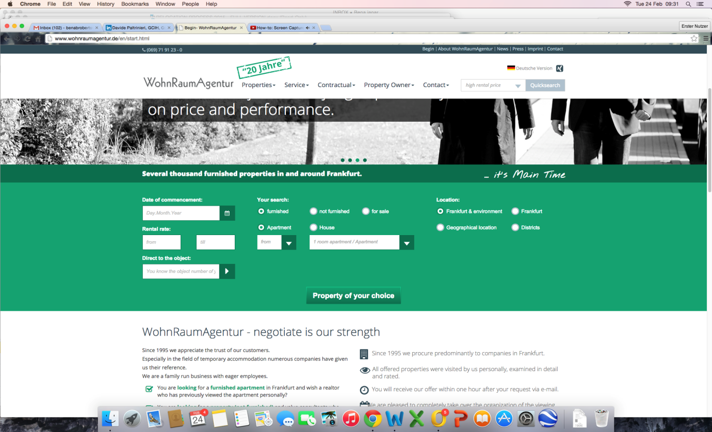
An alternative for furnished property in Frankfurt would be ... www.city-residence.de
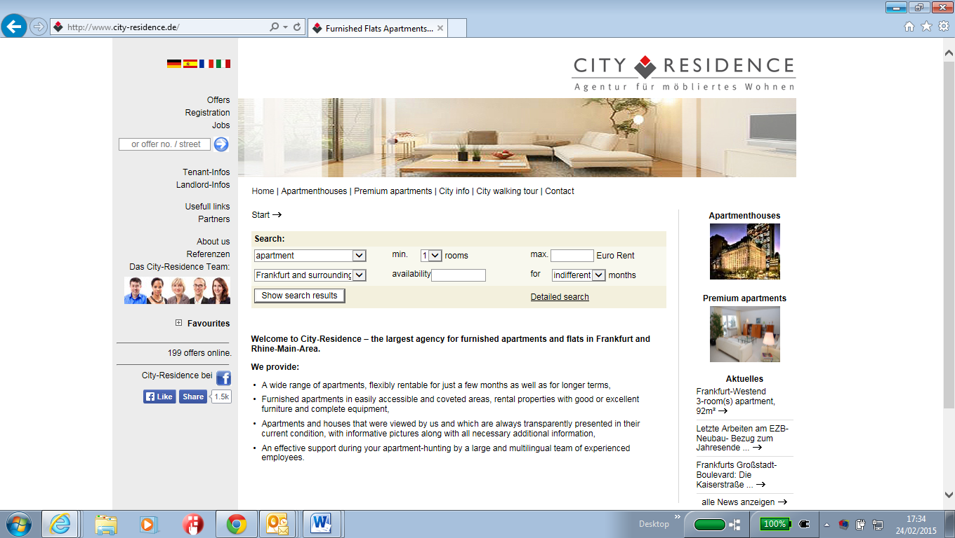
Your Property Sourcing agent will represent you in the search for furnished property, dealing directly with WohnRaum / City-Residence / Landlords and overseeing the entire process on your behalf, including contract signing and handover.
This guarantees that this process is concluded with minimum stress.
Dependant on your circumstances your Property Sourcing expert can also assist with securing unfurnished apartments in and around the Frankfurt area, dealing directly with Landlords on your behalf ensuring a quick, stress free relocation.

You can assist with this process – A large selection of unfurnished property can be viewed on the following site: www.immobilienscout24.de

Once you have identified your preferred choice of property on ImmobilienScout (Germanys largest online property rental portal) – Your Property Sourcing agent will then act as an intermediary between you and the landlord to assist in securing the property – This service will also involve confirming availability, arranging / attending viewings and reviewing rental contracts.

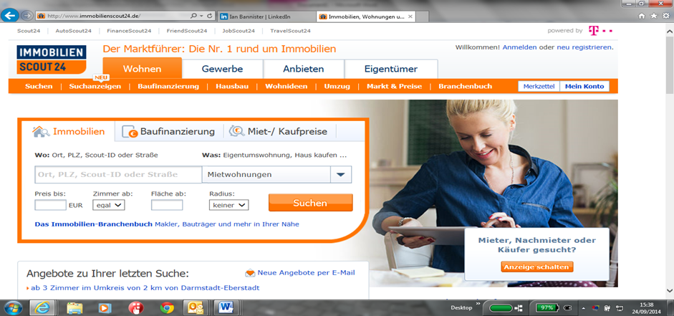

10 key Benefits of the new Serco Property Sourcing Solution
- Easy to understand solution.

- Agent fluent in both English and German language – Will act as single point of contact between you and Management companies/Property owners.

- Agent offers a solution tailored to your individual circumstances.

- Furnished accommodation can often be secured on-line, prior to your arrival in Germany meaning and can therefore arrange mail forwarding in advance.

- Reduced initial financial outlay.

- Fully Furnished accommodation available, fully equipped to limit your initial financial outlay required on furniture, kitchenware, bedding etc.

- Fully Inclusive properties are often available – further reducing the stress of managing finances: fully Inclusive means that your monthly rental payment includes utility bills, in some properties internet and even a cleaner are included.

- Short term flexible contracts available in a selection of properties – Short term furnished solutions offer you additional time to discover Frankfurt and the surrounding area, before making a long term housing commitment.

- As the person named on the tenancy agreement, YOU own the deposit. If you leave the property the owner returns the deposit directly to your bank account (or the person named on the rental contract).

- Rental contract directly between YOU (employee) and the landlord.

