CV OF PROPOSED PERSONNEL

PERSONAL INFORMATION

Title: Choose an item. | Surname:
First Name: | Date of birth:
City of birth: | Country of birth:
Present Nationality:
Do you require a permit to work at the location indicated in the vacancy?

EDUCATION

- Formal Education
 | Name and Location | From mm/yy | To mm/yy | Full-Time/Part -Time | Major Subjects | Degree or Diploma obtained
Secondary School/High school |  |  |  | Choose an item.
Choose an item. |  |  |  | Choose an item.
Choose an item. |  |  |  | Choose an item.
Choose an item. |  |  |  | Choose an item.
Choose an item. |  |  |  | Choose an item.
If required, additional diplomas can be described in the Area of Specialisation.

- Membership of Business Professional Associations, Professional Qualifications
Qualification Received | Awarded by | Subject | From Mmm/yy | To Mmm/yy | Date

- List of patents, publications and other significant work

- Languages
Mother tongue
Other languages | Speaking | Listening | Writing | Reading
 | Choose an item. | Choose an item. | Choose an item. | Choose an item.
 | Choose an item. | Choose an item. | Choose an item. | Choose an item.
 | Choose an item. | Choose an item. | Choose an item. | Choose an item.
 | Choose an item. | Choose an item. | Choose an item. | Choose an item.
*Please list languages in order of fluency and use as reference the Common European Framework of Reference (CEFR) table in Annex 1 to evaluate the candidate’s level.

- Area of specialisation

PROFESSIONAL EXPERIENCE

PRESENT EMPLOYMENT
Company:
Address:
Job title:
Name of Supervisor:
Employment from (mm/yy): | Employment to (mm/yy):
Total years/months of employment:
Description of duties and responsibilities:
Number of employees reporting to you:
Reason for leaving:

PREVIOUS EMPLOYMENT
Company:
Address:
Job title:
Name of Supervisor:
Employment from (mm/yy): | Employment to (mm/yy):
Total years/months of employment:
Description of duties and responsibilities:

Number of employees reporting to you:

Reason for leaving:

PREVIOUS EMPLOYMENT
Company:
Address:
Job title:
Name of Supervisor:
Employment from (mm/yy): | Employment to (mm/yy):
Total years/months of employment:
Description of duties and responsibilities:

Number of employees reporting to you:
Reason for leaving:

PREVIOUS EMPLOYMENT
Company:
Address:
Job title:
Name of Supervisor:
Employment from (mm/yy): | Employment to (mm/yy):
Total years/months of employment:
Description of duties and responsibilities:

Number of employees reporting to you:
Reason for leaving:

For previous employment, please indicate below:

MOTIVATION LETTER

Dear Sir/Madam,
[PLEASE COMPOSE MOTIVATION LETTER HERE]
- Outline what are the main factors that make you apply for this post and your interest in working at ESA/ESTEC at their XXXX Office within ESA’s Directorate of XXXX;

- Describe your experience and link your past experience and your skills with the position requirements: why do you think you will succeed in this role?

Annex 1:
Common European Framework of Reference for Languages

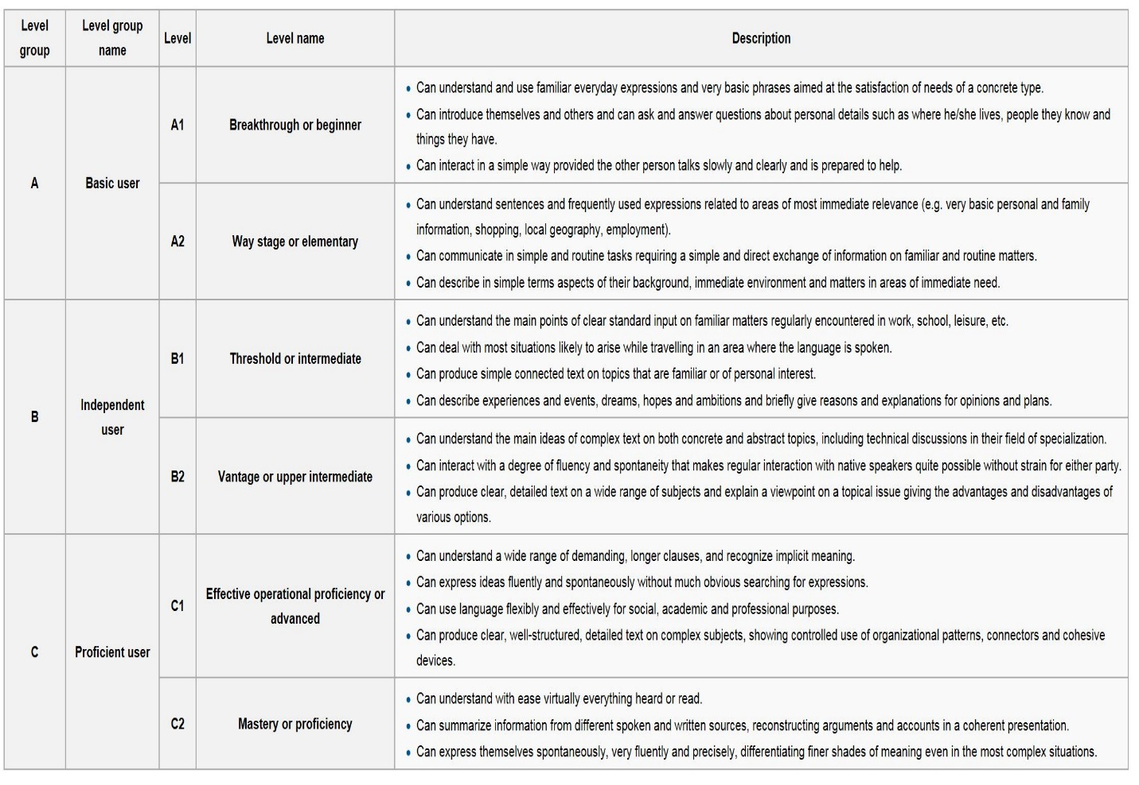

Please indicate total years/months of employment acquired until you submitted your application for this RT.

