Relocation Process 2016

An overview of the assistance offered to new starters

Support of a locally based - German/English speaking Relocation Agent :
Serco Services GmbH are represented by locally based Relocation Management professional Bena Roberts.
Bena provides professional and reliable relocation assistance to Serco employees based at the ECB, she is a proven expert on Frankfurt and surrounding areas and offers a wealth of expertise to assist you with sourcing and securing furnished or un-furnished property.
Your relocation agent will offer a relocation solution tailored to your individual circumstances and provide expertise throughout the entire relocation process.

Complimentary flight (or travel expenditure) :
Single flight (or refund of fuel costs) to Frankfurt Main
Single Flight / travel expenditure also offered to partner + dependants that follow within six months of employee start date.

Complimentary registration Services Provided by Move-Concept :
i. Application for residence permit
ii. Application tax wage document/personal tax ID number
iii. Assistance in finding and registering dependants at School / KinderGarten

Financial assistance provided by Serco.
Serco Services GmbH can offer an Interest loan to assist with the initial cost related to acquiring accommodation sourced through suppliers such as Wohnraumagentur and City-Residence ;
Upfront moving costs will generally involve the following (this may vary) ;
2 months deposit furnished or 3 months deposit unfurnished.
1 month in rent advance (and/or part rent dependent on moving in date).
Final cleaning charge (generally in furnished property only)

The Interest free total loan amount guideline is limited to the net income of a single month salary.
The loan is interest free, deductible from salary with the option to repay over the following terms ;
12 Months,
18 Months
24 months.

For fixed term contracts the loan agreement will reflect the term of the contract with the outstanding loan balance to be deducted from the final salary.
In the event a fixed term contract is extended, the term of the loan agreement can be amended to reflect the extension.

Sourcing property
You can source property from our preferred source of furnished property via the easy to use (English language) search function of the WohnRaum website.

www.wohnraumagentur.de

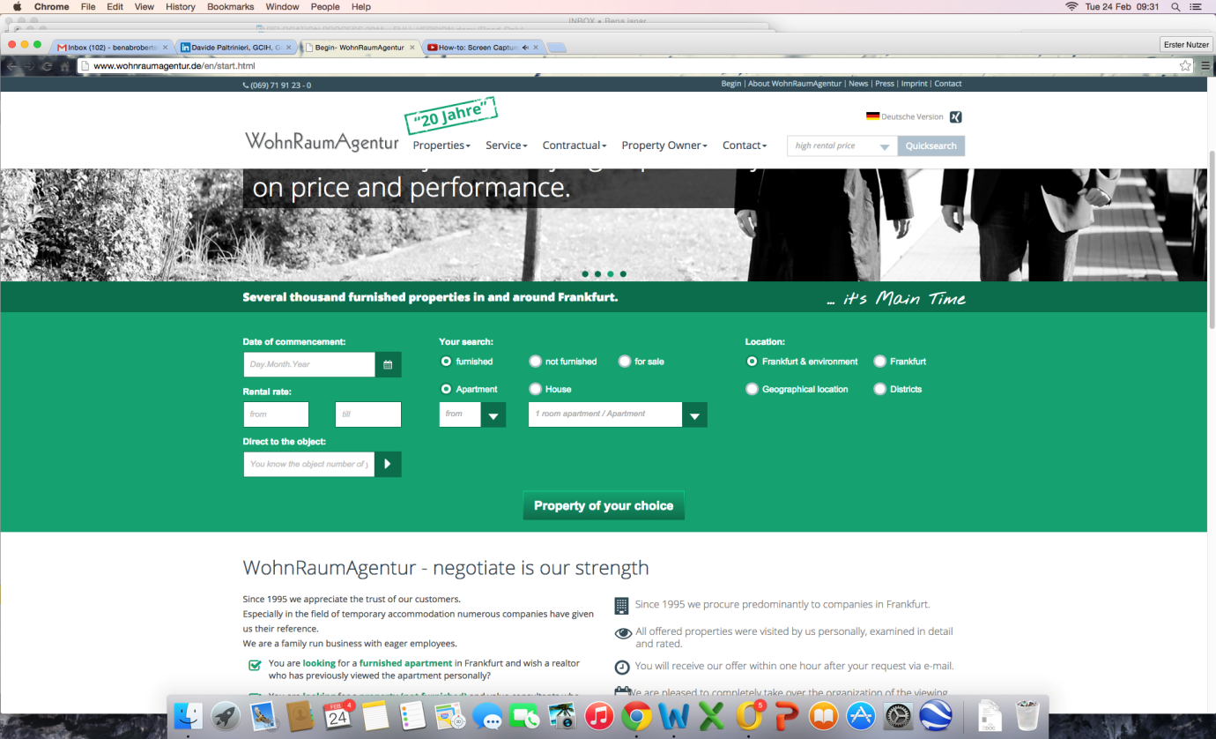

An alternative for furnished property in Frankfurt would be .. www.city-residence.de
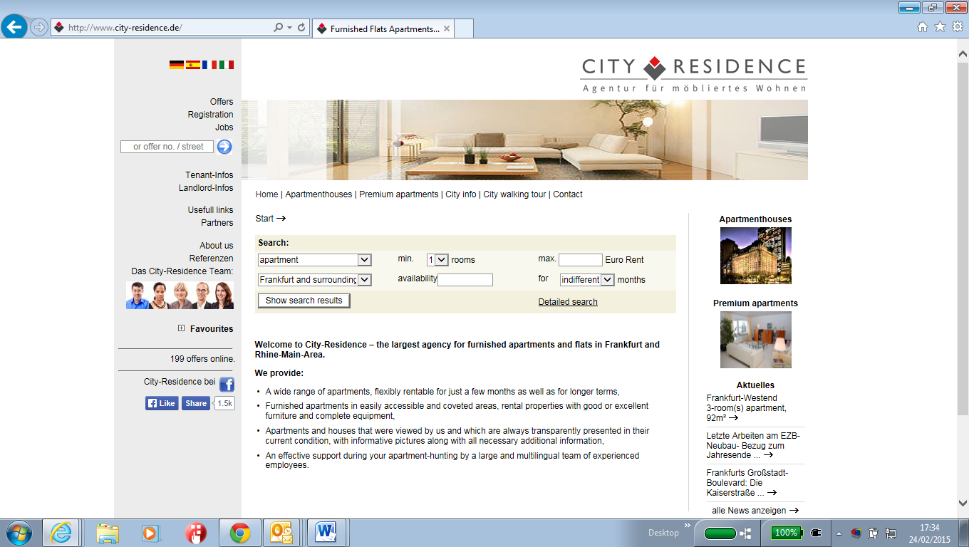
Your relocation agent will represent you in the search for furnished property, dealing directly with WohnRaum / City-Residence / Landlords and overseeing the entire process on your behalf, including contract signing and handover.
This guarantees that your relocation process is conducted with minimum stress.
Dependant on your circumstances your Relocation expert can also assist with securing Unfurnished apartments in and around the Frankfurt area, dealing directly with Landlords on your behalf ensuring a quick, stress free relocation.

You can assist with this process – A large selection of unfurnished property can be viewed on the following site : www.immobilienscout24.de

Once you have identified your preferred choice of Commission free property on ImmobilienScout (Germanys largest online property rental portal) – Your Relocation agent will then act as an intermediary between you and the landlord to assist in securing the property – This service will also involve confirming availability, arranging / attending viewings and reviewing rental contracts.

(To avoid agency fee’s you need to search for “COMMISSION FREE” property on the ImmobilienScout website).

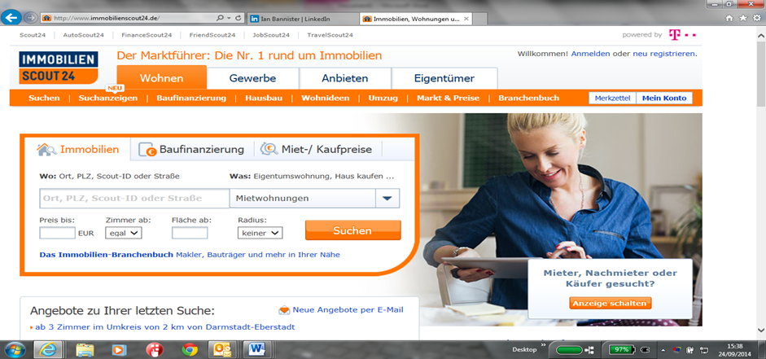

10 key Benefits of the new Serco Relocation Solution
- Easy to understand solution.

- Relocation agent fluent in both English and German language – Will act as single point of contract between you and WohnRaum / City-Residence/Property owners.

- Relocation Agent, offering a relocation solution tailored to your individual circumstances.

- Furnished accommodation can often be secured on-line, prior to your arrival in Germany meaning and can therefore arrange mail forwarding in advance.

- Reduced initial financial outlay.

- Fully Furnished accommodation available, fully equipped to limit your initial financial outlay required on furniture, kitchenware, bedding etc.

- Fully Inclusive properties are often available – further reducing the stress of relocation : fully Inclusive means that your monthly rental payment includes utility bills, in some properties internet and even a cleaner are included.

- Short term flexible contracts available in a selection of properties – Short term furnished solutions offer you additional time to discover Frankfurt and the surrounding area, before making a long term housing commitment.

- As the person named on the tenancy agreement, YOU own the deposit. If you leave the property the owner returns the deposit directly to your bank account (or the person named on the rental contract).

- Rental contract directly between YOU (employee) and the landlord.

